Instalando bower

<http://bower.io/>

rafael.franco@NOTWEB-O1 MINGW64 /e/PROGRAMAS/www/laravel-angular

$ npm install -g bower

Configurar as variáveis de ambiente

Iniciando

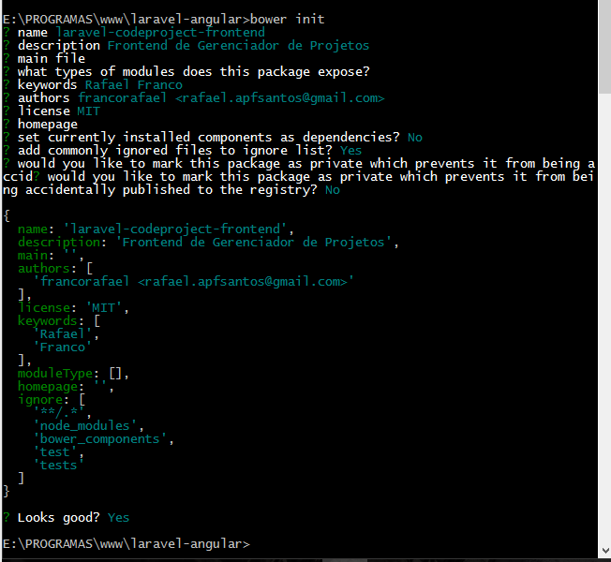

Agora instalar uma biblioteca que esta no bower

Angular

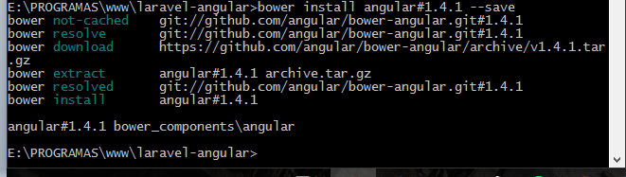

Angular Route

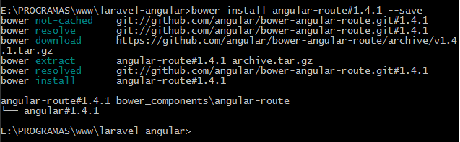

Angular Resources

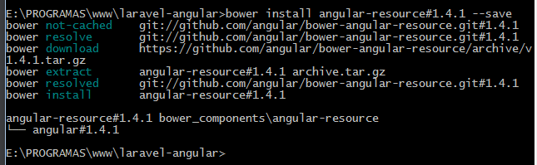

Angular Animate

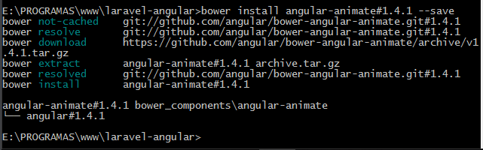

Angular Messages

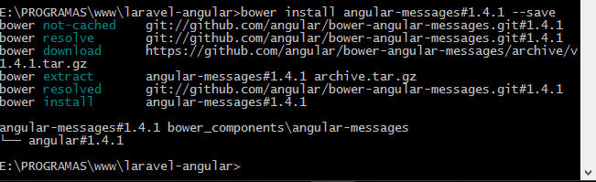

Angular Boostrap

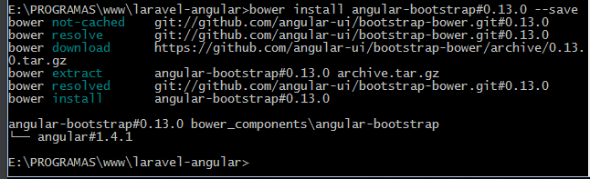

Angular Strap

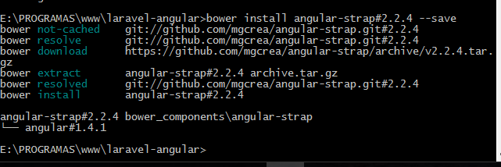

Boostrap

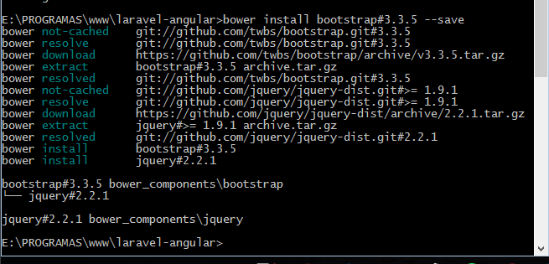

Bower.json final

{  
 **"name"**: **"laravel-codeproject-frontend"**,  
 **"description"**: **"Frontend de Gerenciador de Projetos"**,  
 **"main"**: **""**,  
 **"authors"**: [  
 **"francorafael <rafael.apfsantos@gmail.com>"** ],  
 **"license"**: **"MIT"**,  
 **"keywords"**: [  
 **"Rafael"**,  
 **"Franco"** ],  
 **"moduleType"**: [],  
 **"homepage"**: **""**,  
 **"ignore"**: [  
 **"**/.*"**,  
 **"node_modules"**,  
 **"resources/bower_components"**,  
 **"test"**,  
 **"tests"** ],  
 **"dependencies"**: {  
 **"angular"**: **"1.4.1"**,  
 **"angular-route"**: **"1.4.1"**,  
 **"angular-resource"**: **"1.4.1"**,  
 **"angular-animate"**: **"1.4.1"**,  
 **"angular-messages"**: **"1.4.1"**,  
 **"angular-bootstrap"**: **"0.13.0"**,  
 **"angular-strap"**: **"2.2.4"**,  
 **"bootstrap"**: **"3.3.5"** }  
}